# *Lab 8 – Input Design*

Date assigned: Friday, October 21, 2016

Date due: **Friday, October 21, 2016, 11:59 a.m.**

**Learning Objectives**

Upon successful completion of this assignment, the student will be able to:

* Choose appropriate implementation methods for inputs
* Identify appropriate validation techniques
* Evaluate the effectiveness of different input designs

To do:

**Part 1: Input Design**

**Record all your answers in bold in a copy of this document named YourUserName_E11_L08.docx, e.g. JSmith_E11_L08.docx, and saved in the Labs folder in the 420-E11 folder in your H drive.**

1. What would the most appropriate input control be for each of the following inputs? Indicate why. **(6 marks)**
   1. Entering a customer’s meal order in a restaurant
      1. Drop down box
   2. Entering a student’s answer to a multiple choice test that was completed in a classroom
      1. Drop down box
   3. Entering personal information in an on-line registration form
      1. Input fields
   4. Entering the city where you live
   5. Indicating if your pet is neutered.
      1. Radio buttons
   6. Indicating if you are male or female.
      1. Radio buttons
2. Identify *all* (more than one) validation techniques that should be used for each of the following fields on the following form. (Sequence, Existence, Format, Range, Limit, Consistency, Combination, Self-checking digits) **(5 marks)**

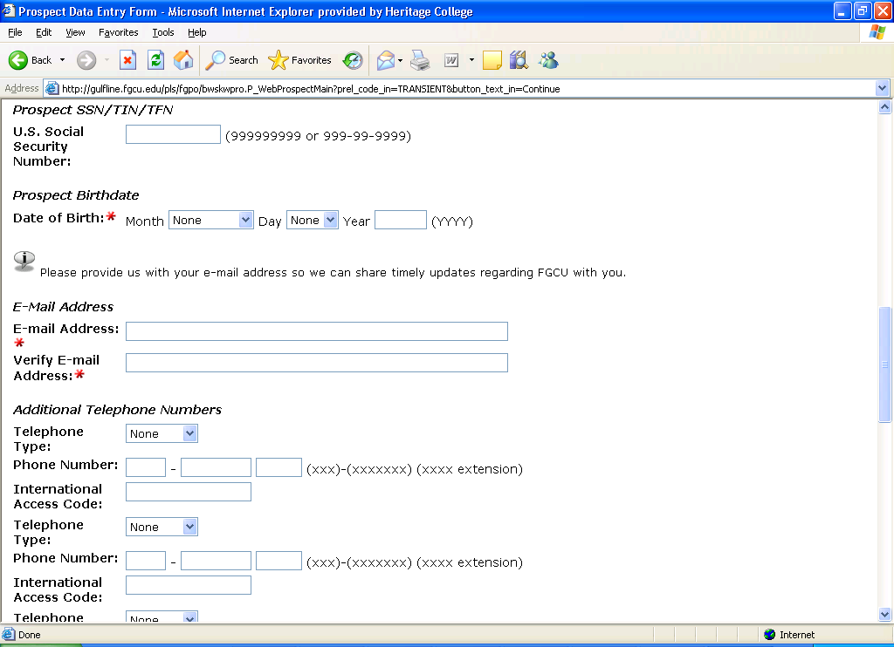

* 1. Social Security Number:

**Self-checking digits**

**Sequence**

* 1. Date of Birth

**Completeness**

**Consistency**

**Range**

* 1. E-mail Address

**Sequence**

**Completeness**

* 1. Phone Number

Range

Self-checking digits

* 1. International Access Code, which must be between 0 and 1000

Range

Self-checking digits

1. Each of the following web sites has a different technique for entering dates. **(6 marks)**

<http://www.expedia.ca/daily/enc4105/home/default.asp>

<http://www.viarail.ca/en_index.html?wt.ad=english_link_view&wt.ac=click_English_link>

<http://www.aircanada.com/en/home.html>

<https://www.united.com/web/en-US/default.aspx?pos=CA>

* 1. For each site, identify how error handling occurs when invalid dates are entered. Try the form with invalid data (try a date of November 31, or mix up the month and day (24/11 instead of 11/24) or try a date in the past for the dates and document any error messages that are displayed or behavior that is used to prevent the error. Which is your preferred method for entering a date and **why?**

**Expedia will give you a calendar to force you to enter a valid date and will check blank fields along with identical destination and arrival points for flights. If you leave any field blank it won’t validate.**

**Via rail will accept past dates if you enter the date manually as opposed to using their date picker. Otherwise their validation is the same as Expedia’s.**

**Air Canada will accept nothing outside of the valid data. They accept only dates picked from their date picker, they don’t accept you to enter the same departure/destination, you must enter all information, they’re very strict on validation.**

**United also has very good validation. They have very few fields initially, but then you can view all available airports by country> state > airport, which is very nice. Once you view all available flights, they have all the upcoming flights listed that match the criteria. I didn’t really find a way to break it.**

* 1. Which is your preferred method for error handling, **why**??

**My favorite site was united. Their error handling was quite robust and they provided additional functionality in allowing you to select from a list of airport organized the way they had it.**

1. Identify 4 different ways in which the following form could be corrected or improved: **(4 marks)**

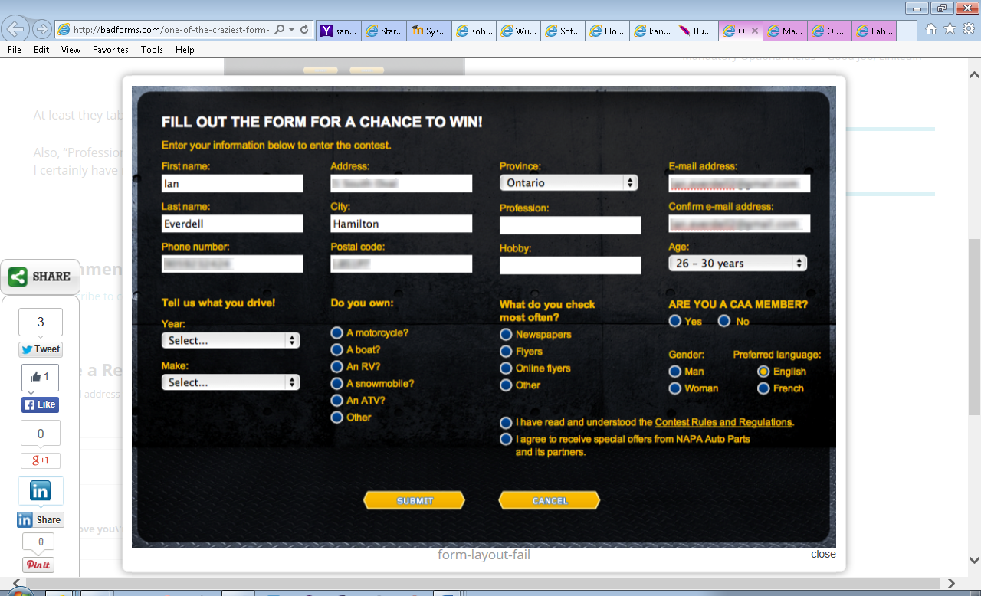

**I would structure the form very differently. I would make it so that all related fields are grouped together horizontally, so like**

**First name : _____________ Last name: ________________________**

**Address: _____________ City: ______________ Province: _____ Postal code: ________**

**Etc…**

**I would also make more of a visual differentiation between the radio buttons and the check boxes. They look identical, which could be slightly confusing.**

**I’d add third options for both gender and preferred language to include other.**

**I’d also have two separate drop downs for the make of a car, one being the manufacturer and the other being the model. Otherwise there’s just a lot of different types of cars to scroll through.**

**Placeholders of the form input fields might also not be a bad idea.**

**The form also gives no indication as to what fields are required.**

1. Identify 2 different ways in which the following form could be corrected or improved: **(2 marks)**

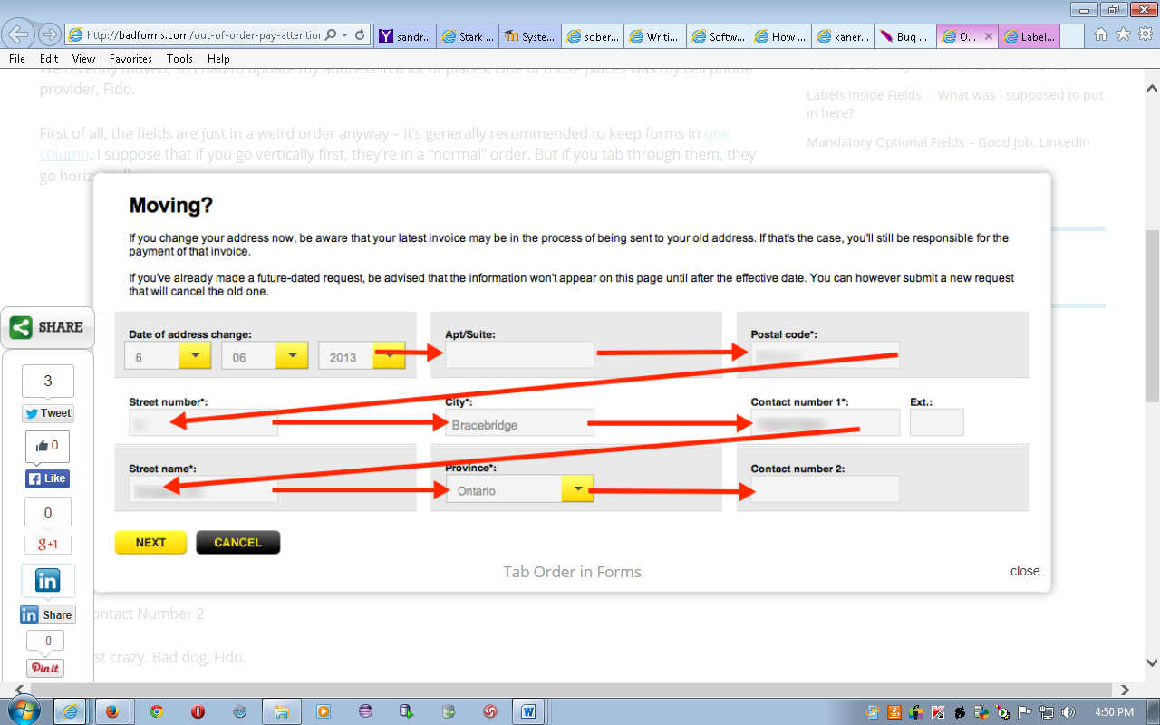

**Well first of all, the red arrows don’t look too good…**

**Like the first form, I would restructure this one. Put all the relevant information together, group the address info across two lines, with the contact information on another, grouping together mandatory and optional fields. More like:**

**Address: _______ ___________ city: __________ Province: [ON | v] Postal code: _________**

**Apt/Suite: __________ Date of address change: [01 |v] [01 |v] [2016 |v]**

**Contact Number 1: ___________ Ext: _____ Contact number 2: _____________ Ext:_____**

**This way you have a more logical organization of the data along with a much easier to follow tab order.**

**I also added an extension to the secondary phone number for sake of consistency. The fact that each piece of information is grouped into their own little boxed also looks kind of weird, I’d put it also into the same container and give it all the same common look and feel. This looks like everything is broken off and separate.**

**I’d also add placeholders for the phone number field to show the user the format to enter so that it can be more easily validated.**

**To submit**

When you have completed the lab exercise, submit the following document to Moodle:

* **YourUserName_E11_L08.docx**

**Use the rest of your lab to work on assignment 3b.**